**Lab -2**

**Twitter & Hadoop data ingestion**

Create Twitter App

Ingest data via NiFi pipeline

# Twitter Account

1. Create Twitter account

# Create Twitter App

1. Go to <https://apps.twitter.com/>

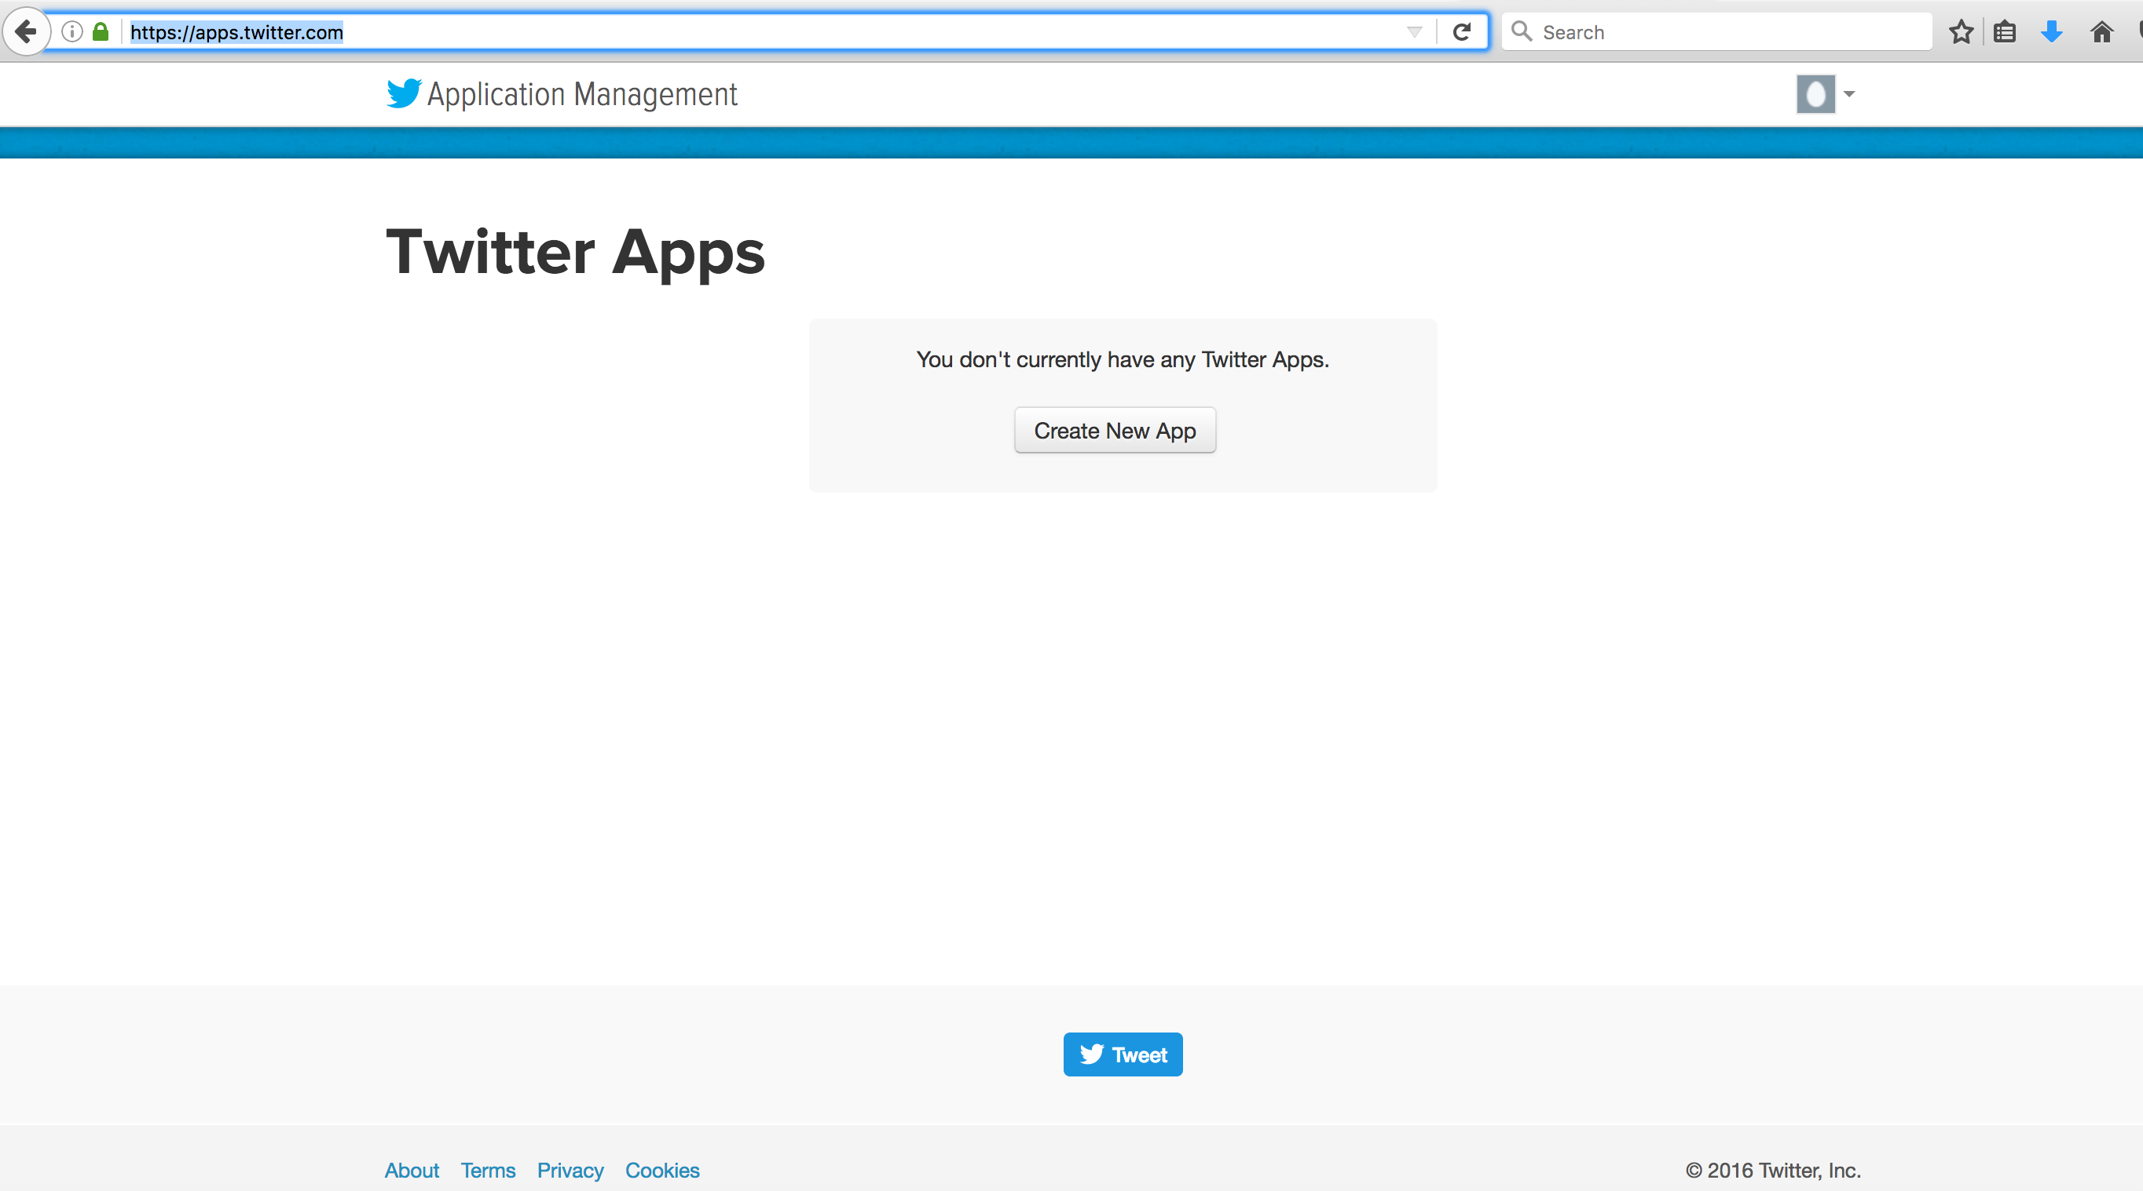

* 1. Create Twitter App

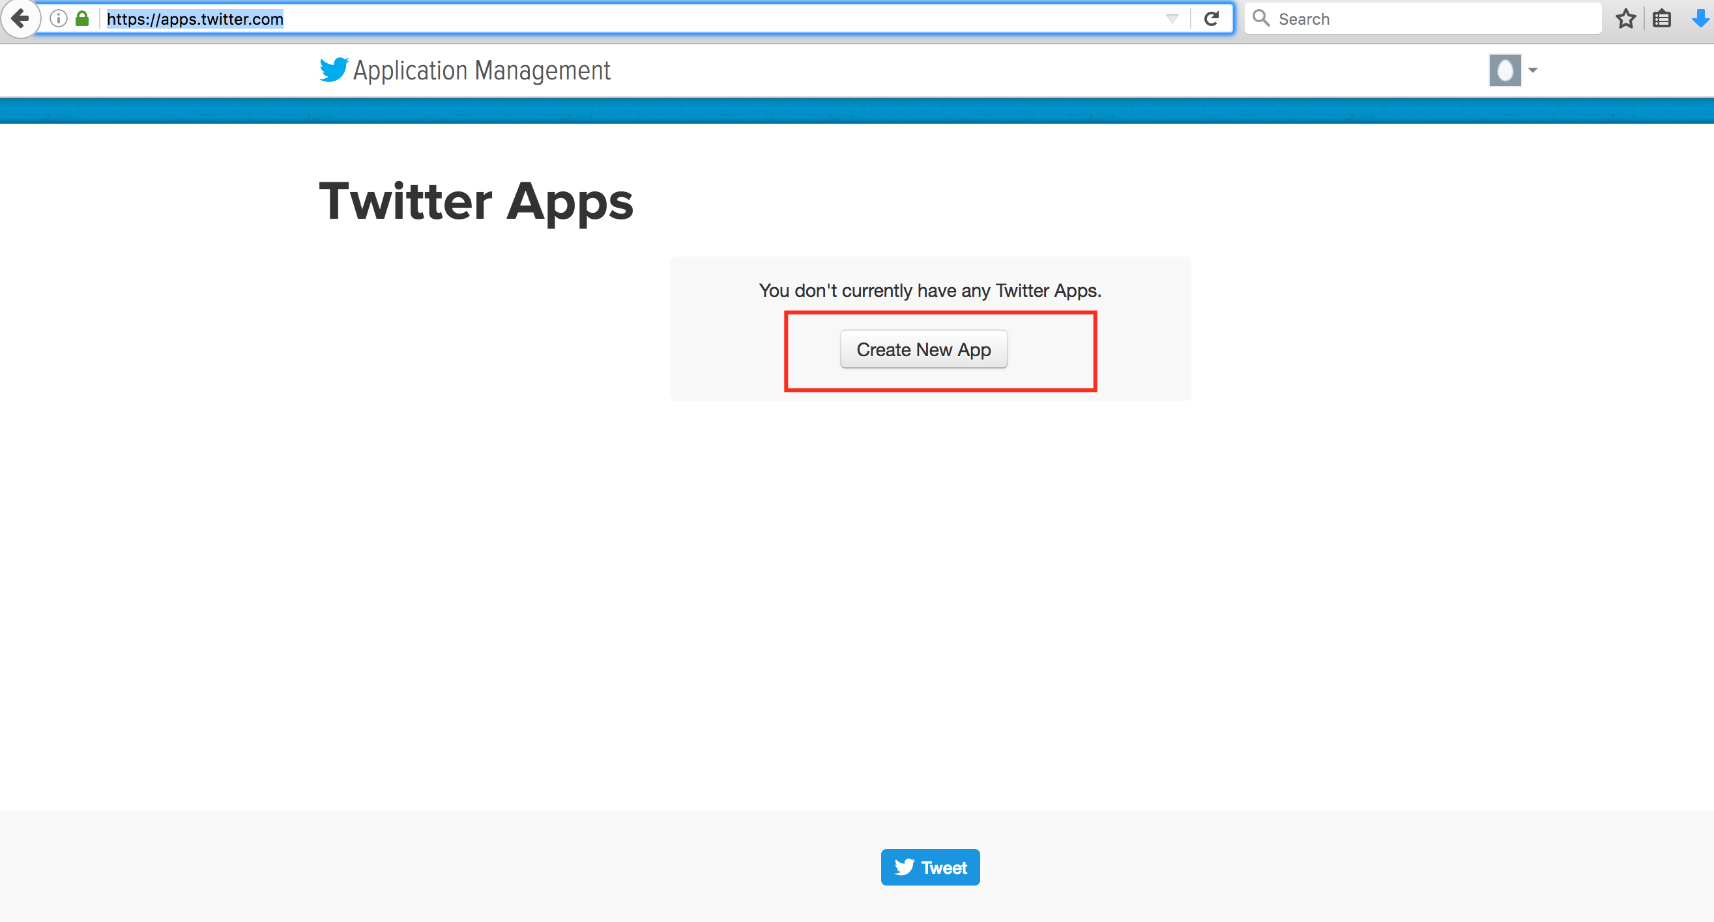

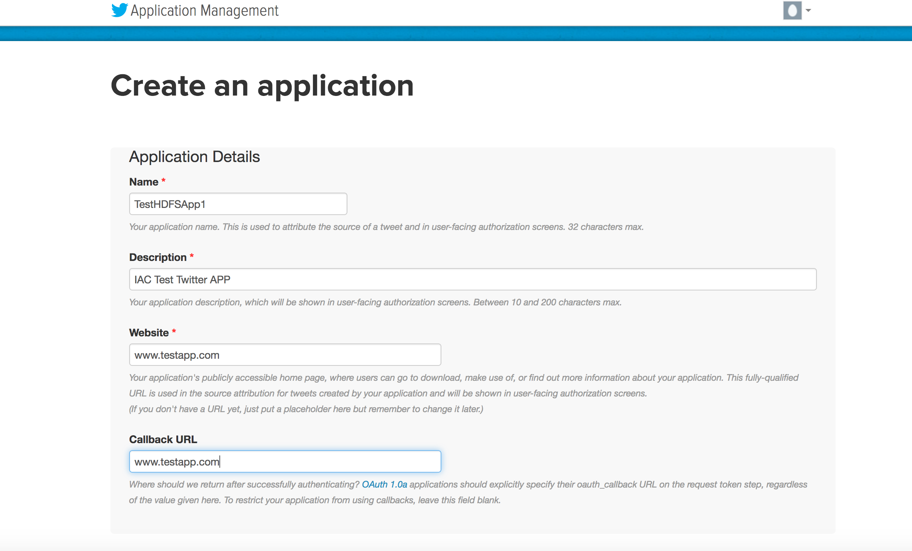

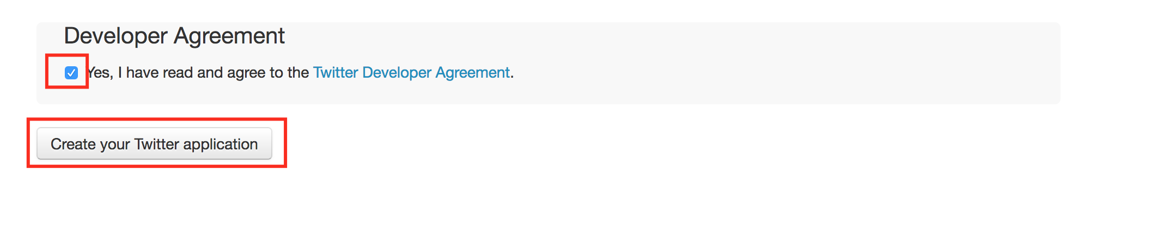

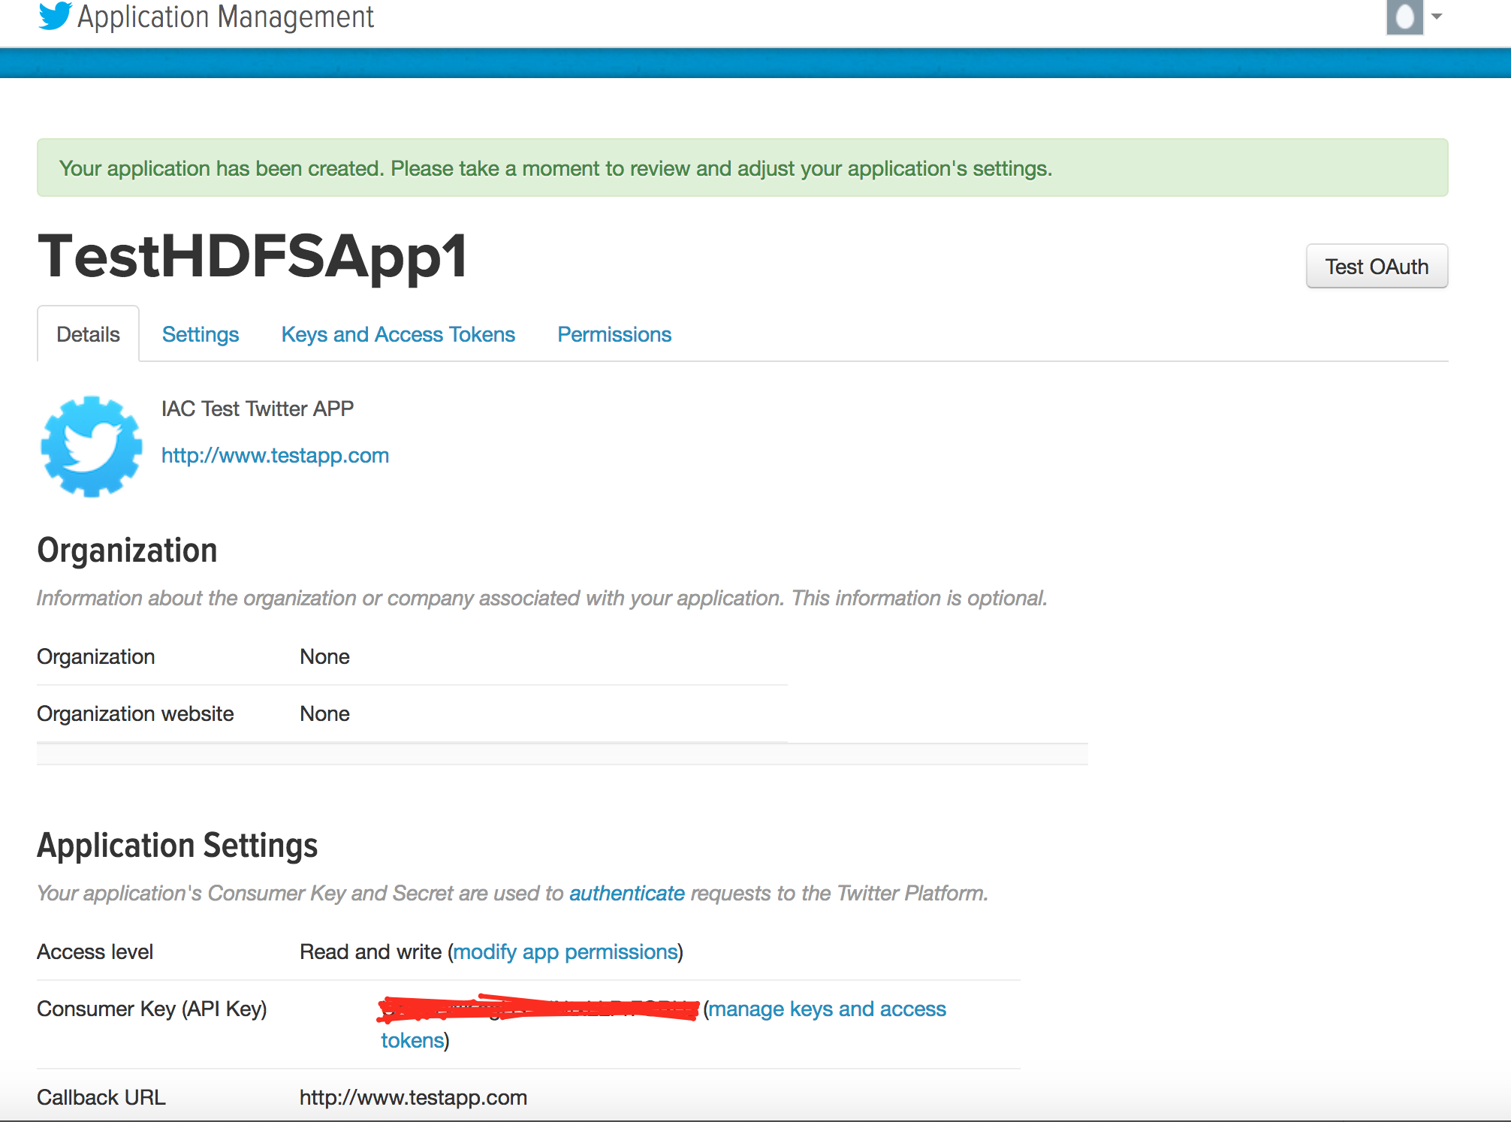

*Note*: “Application name can be anything you may want to be”

* 1. Twitter Application Authentication

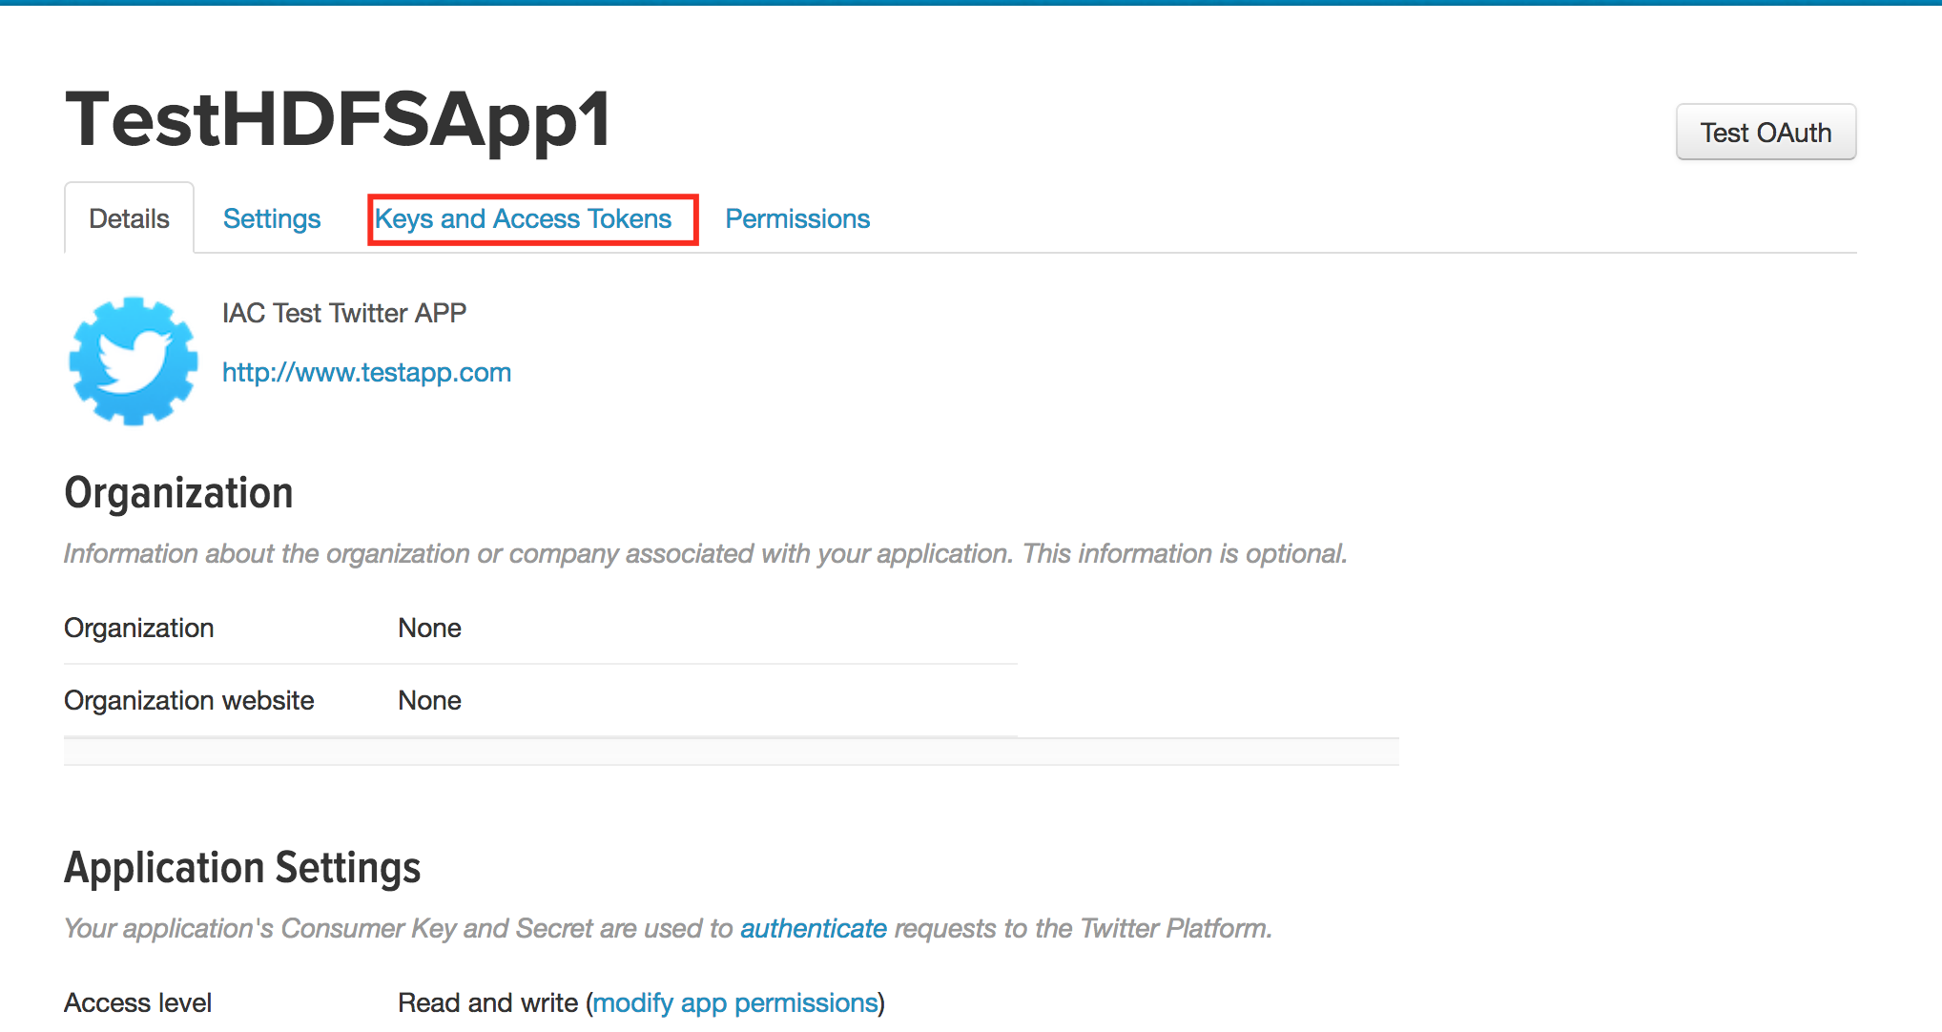



* 1. Generate Access Token

